- Install Jenkins and run Jenkins on port number 8081.
Create EC2 Instance and connect to ssh.
Update packages → sudo yum update -y
Sudo yum install java-17-amazon-corretto -y
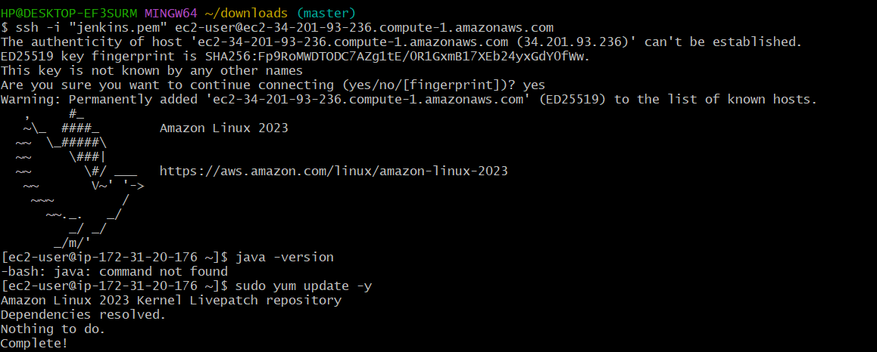
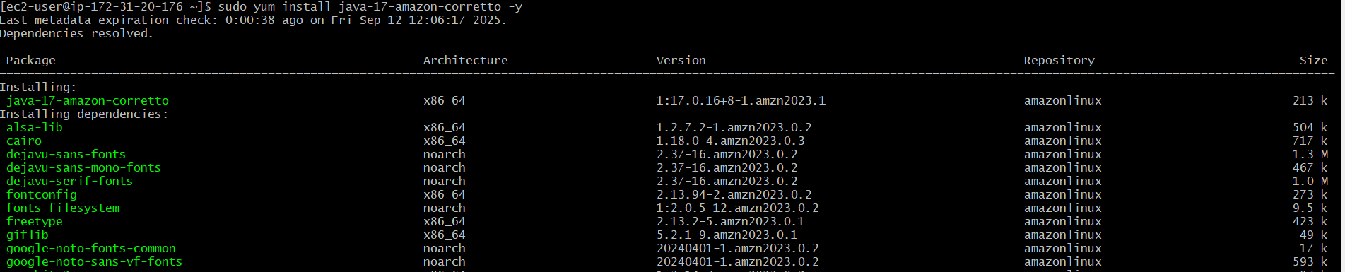
To check java version use → java -version
Add Jenkins repository & install Jenkins :
sudo wget -0 /etc/yum.repos.d/Jenkins.repo
\https://pkg.jenkins.io/redhat-stable/Jenkins.repo

Sudo rpm -import https://pkg.jenkins.io/redhat-stable/jenkins.io-2023.key
Sudo yum install Jenkins -y

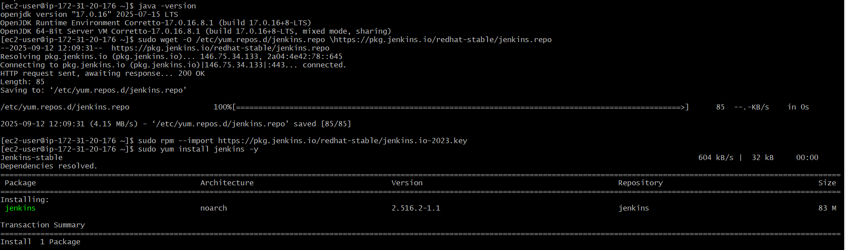

→ Start and enable Jenkins
Sudo systemctl daemon-reload
Sudo systemctl start Jenkins
Sudo systemctl enable Jenkins
Now we can check in the browser with port no:8080
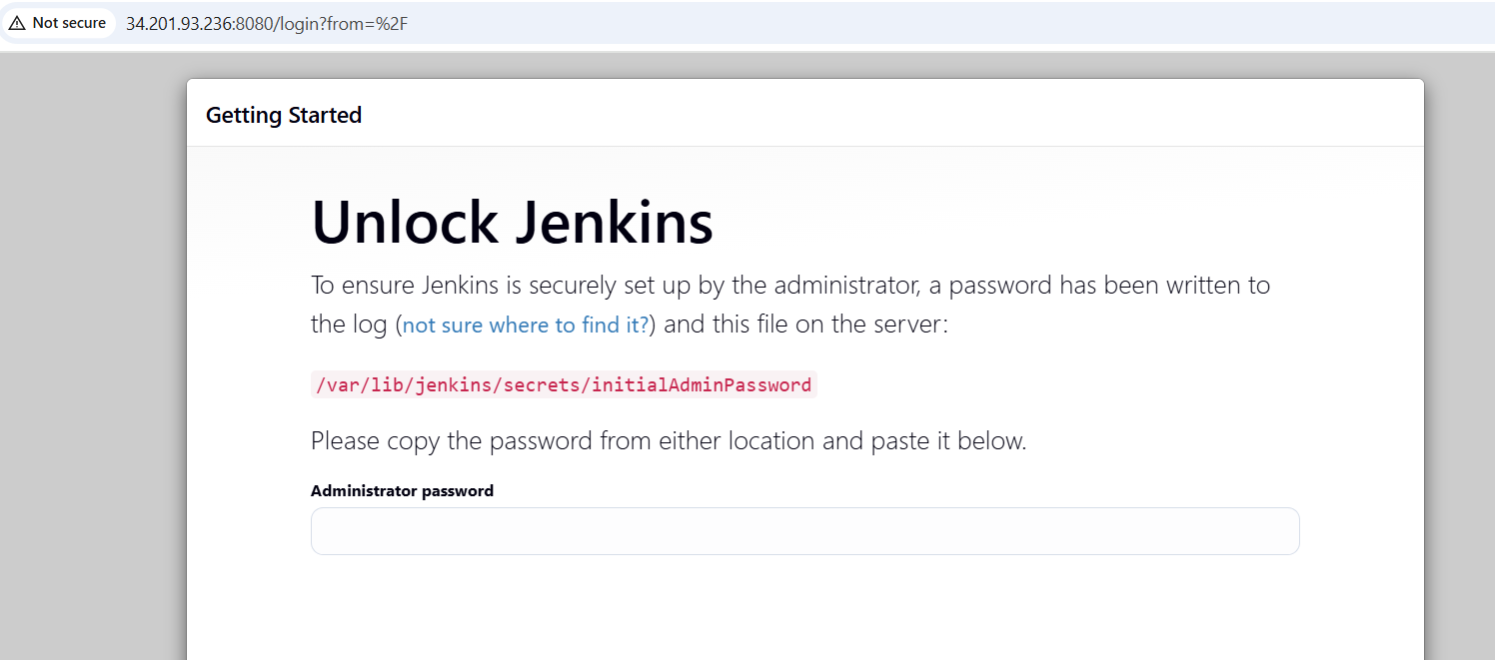
To make Jenkins run on port no:8081
- Sudo vi/usr/lib/systemd/system/Jenkins.service
- Update → Environment=”JENKINS_PORT=8081”
- Sudo systemctl daemon-reload
- Sudo systemctl restart jenkins
- Sudo systemctl status Jenkins
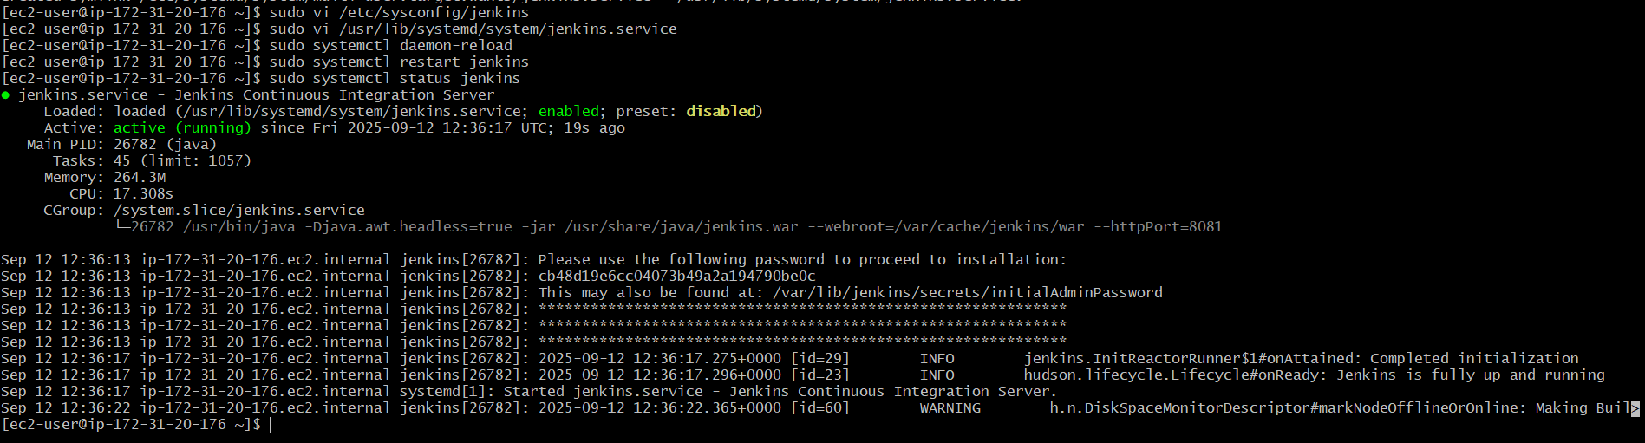

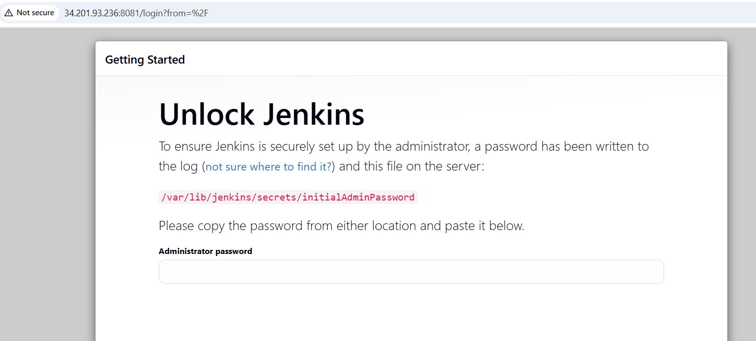

- Secure Jenkins server.
Sudo cat /var/lib/Jenkins/secrets/initialAdminPassword
Copy the above password and paste it in the Administrator password
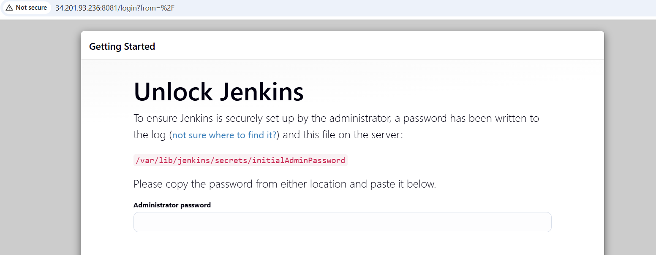
After pasting Administrator password
Click continue
Select → install suggested plugins
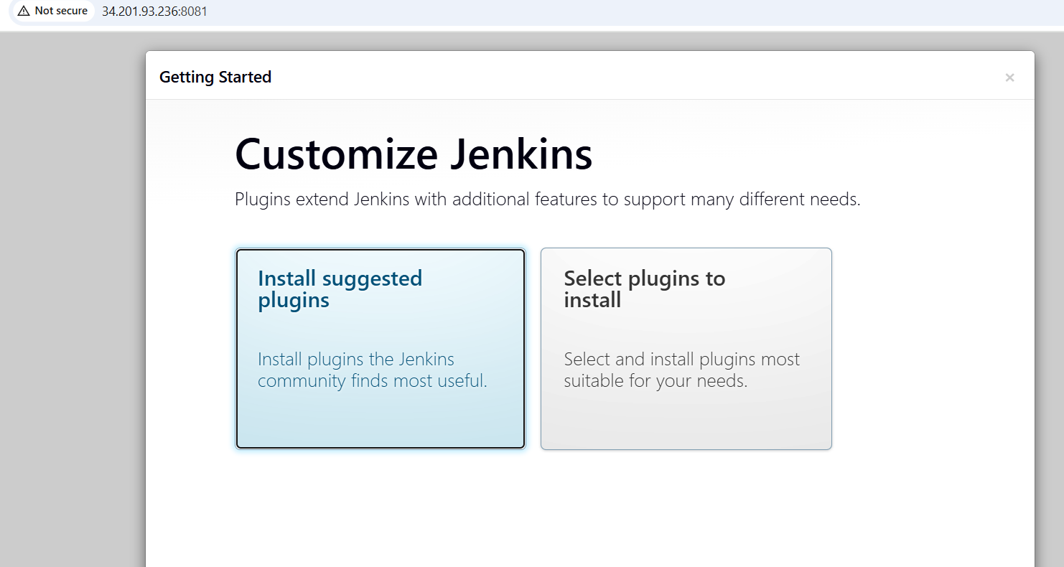
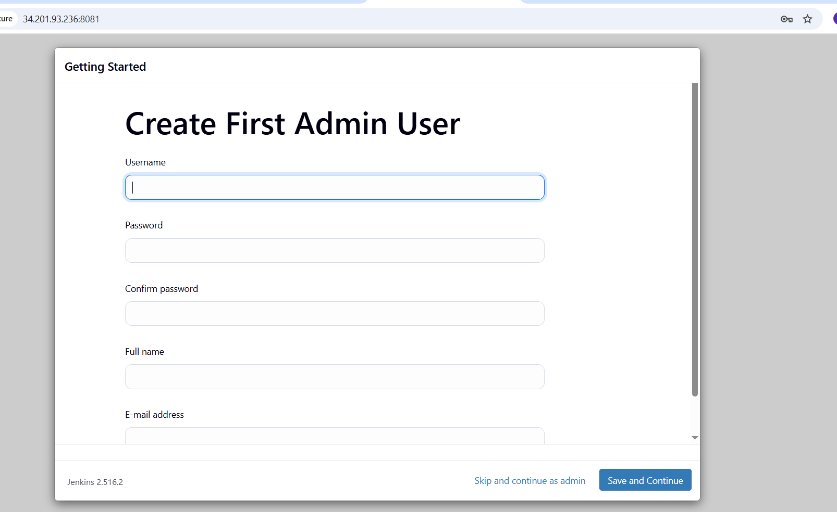
Add username – Admin
Enter password and conform it
Then Save and continue .
- Create users called Devops, Testing in Jenkins with Limited access.
Go to Manage Jenkins → Click create User.
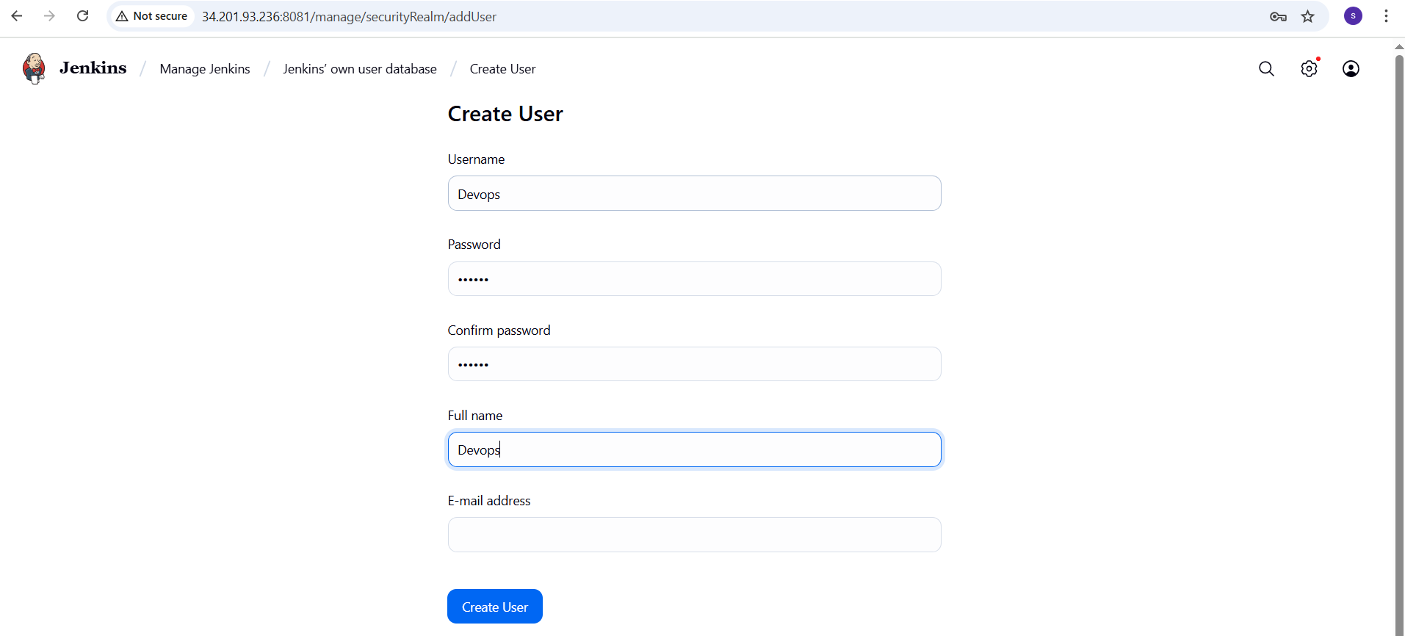
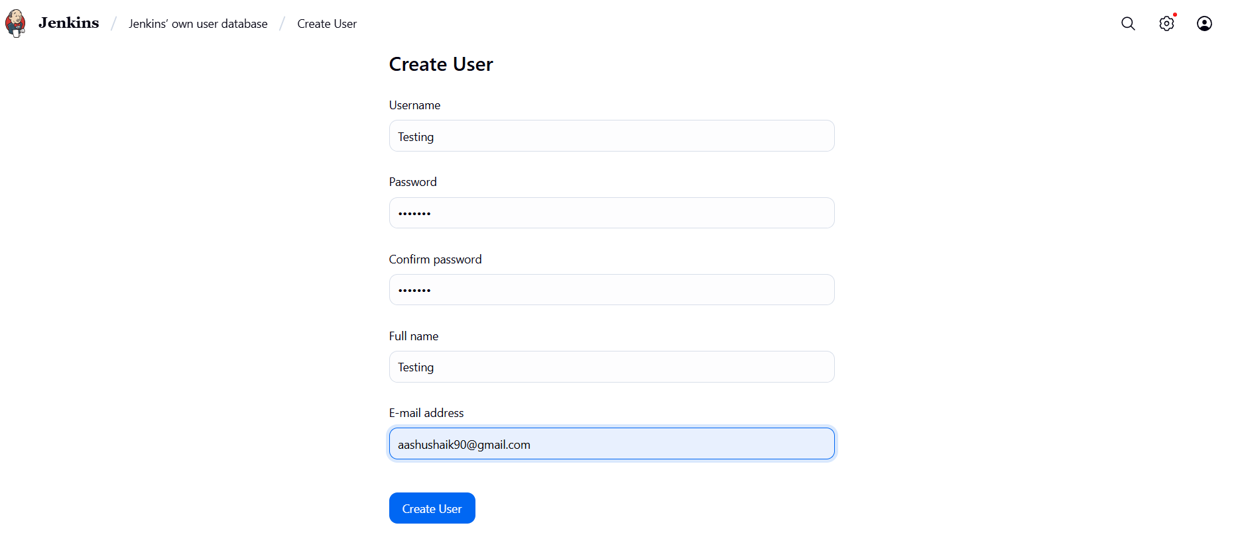
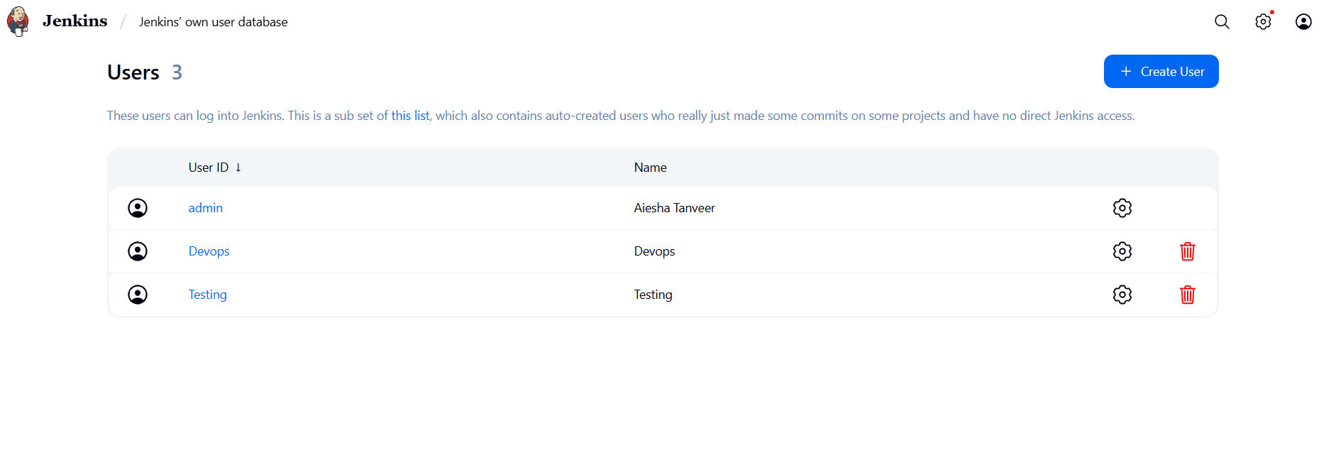
To give limited access:
Go to manage Jenkins → Security → Authorization → Project based Matrix Authorization strategy.
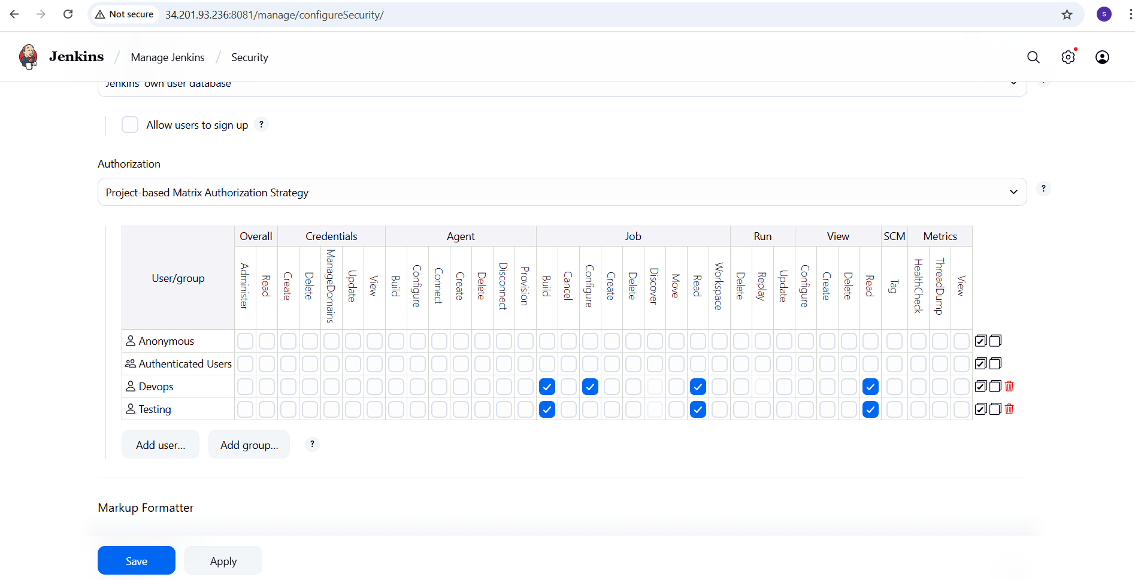
Login to testing
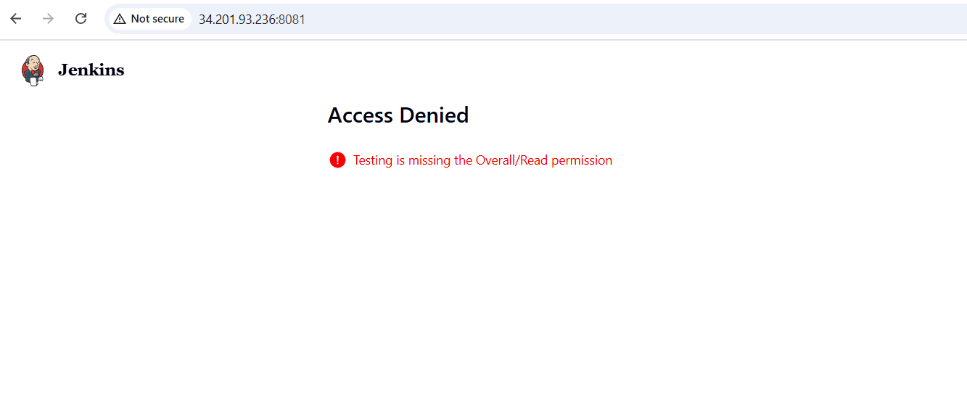

Login to Devops
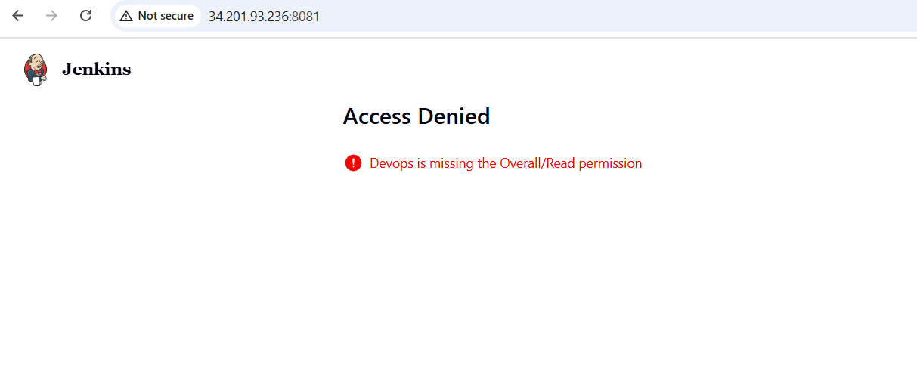
- Configure labels and restrict the jobs to execute based on label only.
To install Git
Sudo yum install git
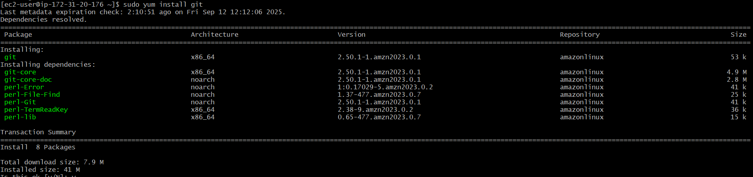
Manage Jenkins → System → Create label master
Create first-job having label master
Create Second-job without label master
Create third-job with wrong label hotfix

In each job → Configure → Build steps →Execute shell → Give seconds
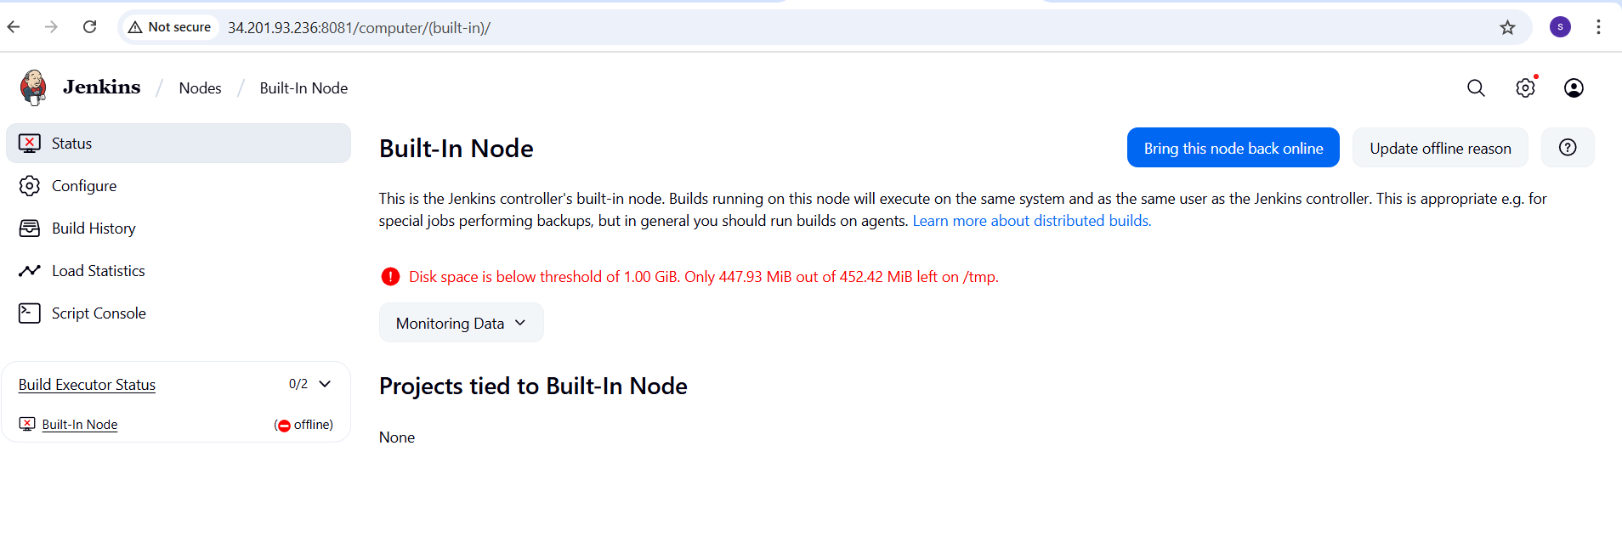
I got an issue with disk space.
Create a new temporary directory :
Sudo mkdir -P /var/lib/Jenkins/tmp
Sudo chown -R Jenkins:Jenkins/var/lib/Jenkins/tmp
Sudo systemctl edit Jenkins → Environment=”JAVA_OPTS=Djava.io.tmpdir=/var/lib/Jenkins/tmp”
Then reload → sudo systemctl daemon-reload
Sudo systemctl restart Jenkins
Then check the created items
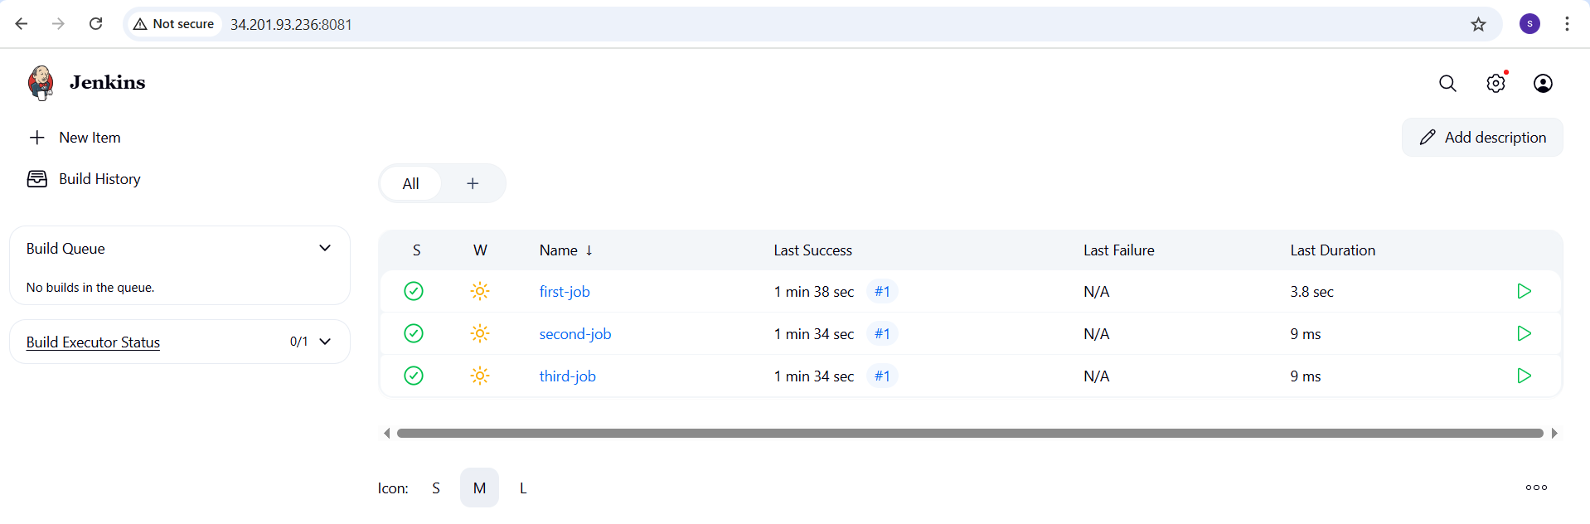
- Create three sample jobs using the below URL.
https://github.com/betawins/Techie_horizon_Login_app.git
Jenkins server should have git installed. → yum install git
Git -version

Go to new item → freestyle project → name :
Under source code management → select git → enter repo URL
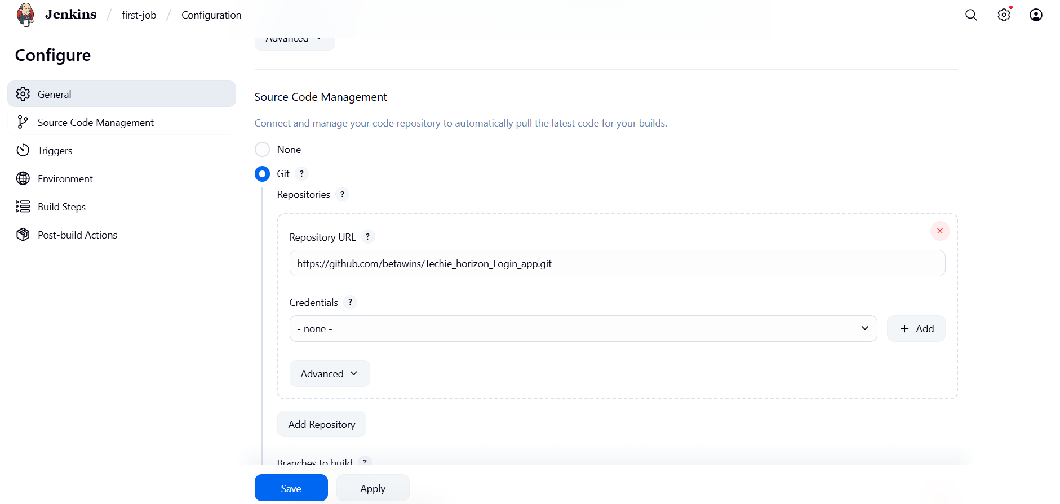
Save and Build.
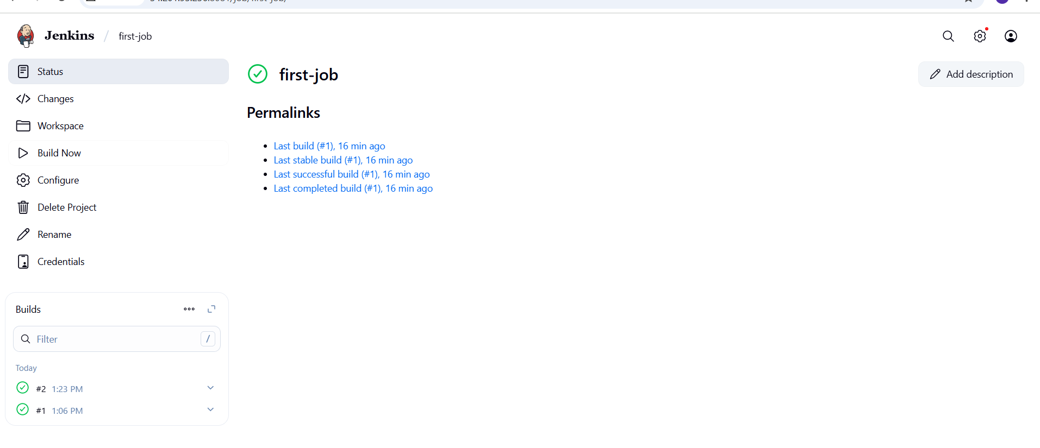Check all the three items are executed with label master.
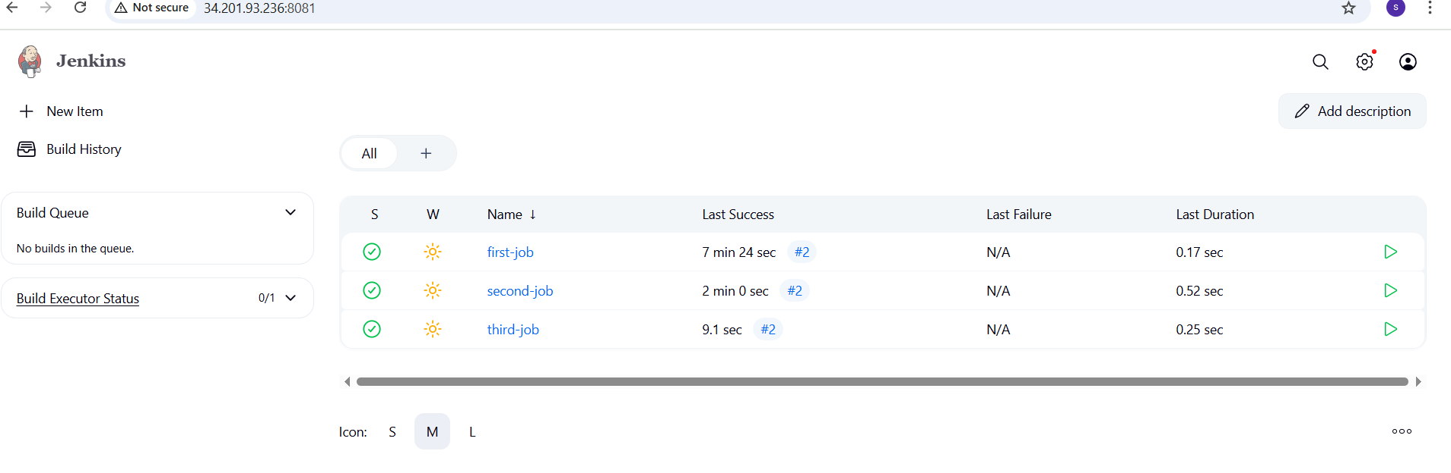
- Create one Jenkins job using github private repository.

Go to github and create private-repo
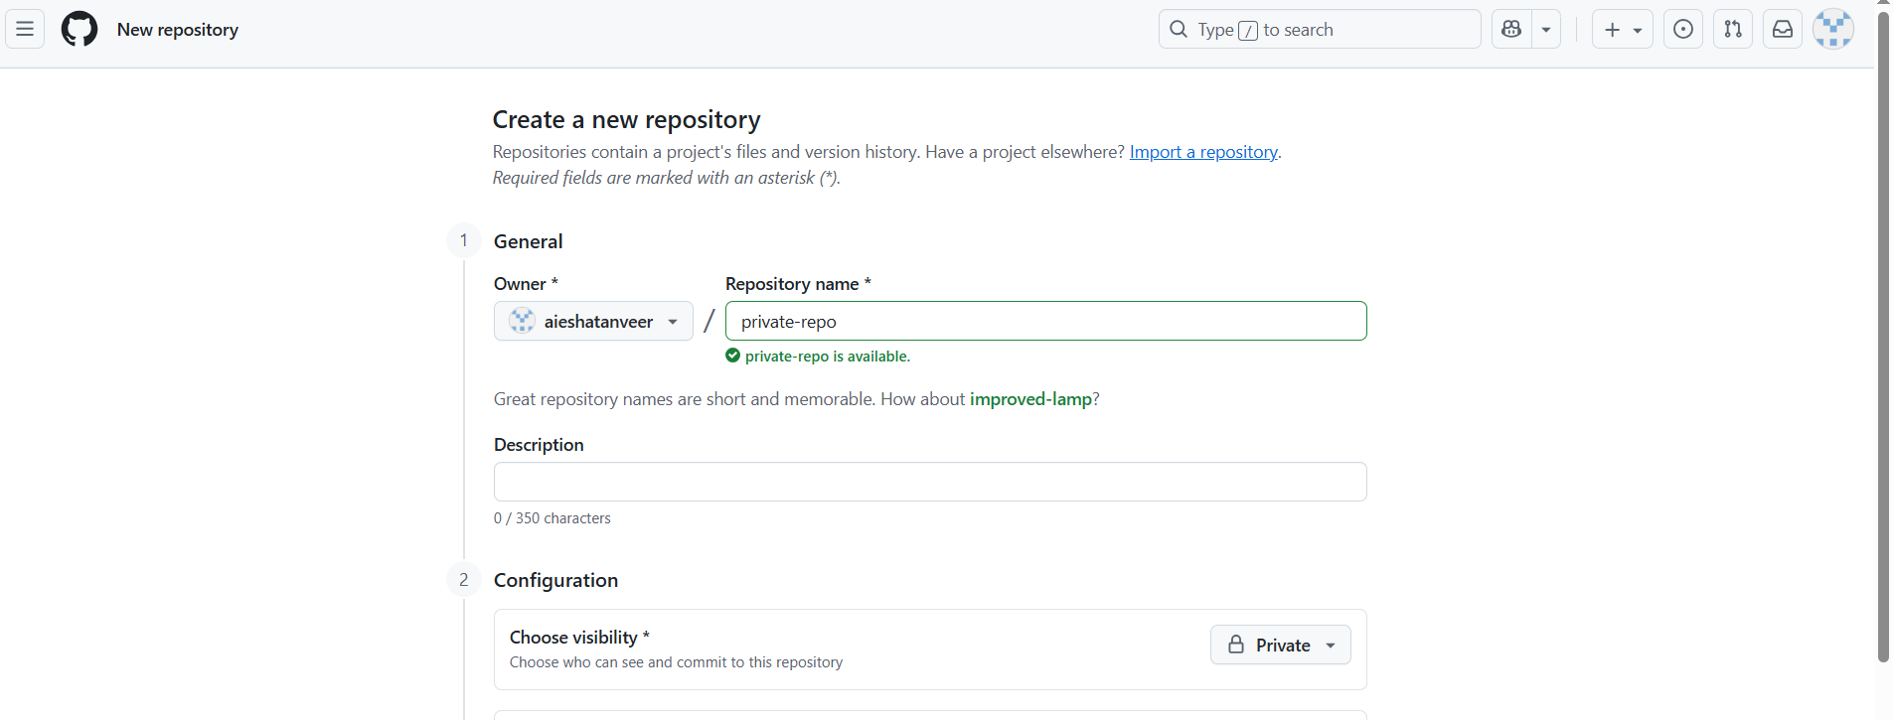
Go to github and create access token with repo
Github → settings → developer settings → personal access tokens → tokens → generate new token → click on generate new token.
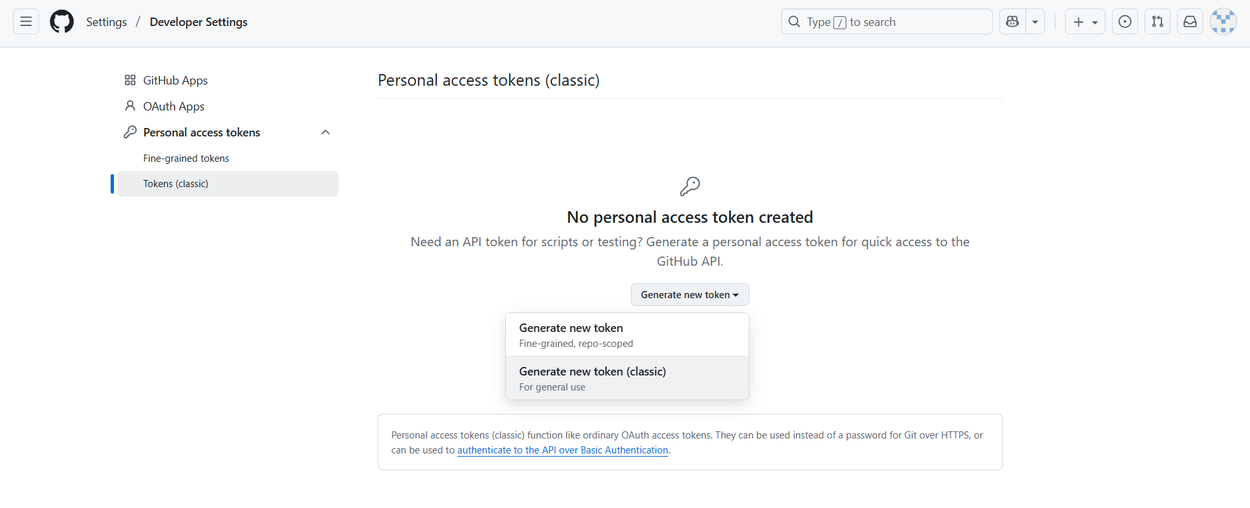
Enter Node → select Repo → Click on generate token
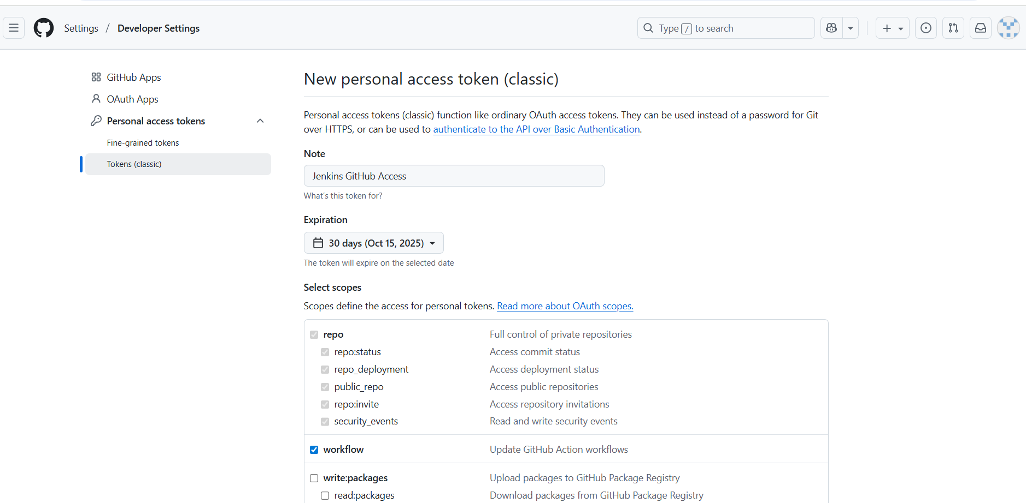
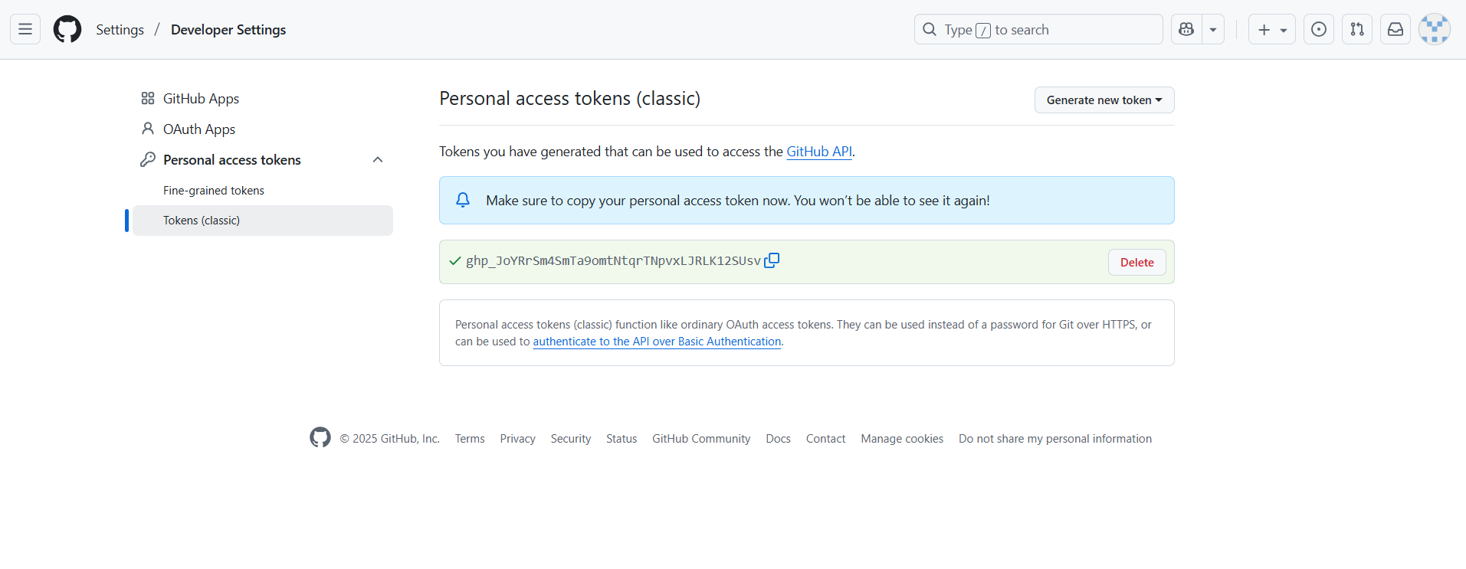

Go to Jenkins → manage Jenkins → credentials → system →global credentials (unrestricted)

In Jenkins create credentials with github username and generate path
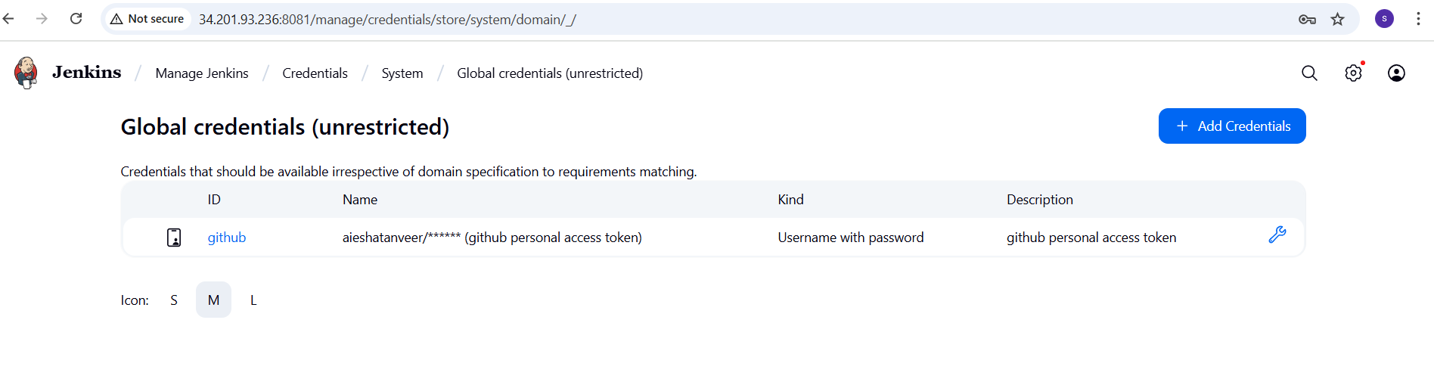
Create private-job with private URL with credentials a run build.
